Word Style Document 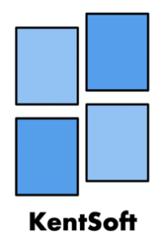

Here at KentSoft we like to keep things consistent as we believe consistency is key to both ours and your success. This document sets a precedent for all other documents that we will need to produce.

Firstly, each document will have our company, KentSoft’s, logo present in the top right, more specifically it will be horizontally aligned to the right relative to the margin and vertically aligned at the top relative to the margin. The size of the logo will be kept the same at a 2.35x3.41cm.

Both the font and font size across all documents will also be kept consistent and will be as follows. The font will be Calibri (body). The heading size will be 28, subheading size will be 16 and paragraph size will be 12. In tables, column headings will be size 12 font with font weight 700 with the contents of the table following the regular page settings.

The page tittle will always be on the third line of the document and the real content of the document will also always begin on the seventh line of the document.